Chapter 8, Problem 13.

For the circuit in Fig. 8.68, calculate the value of R needed to have a critically damped response.

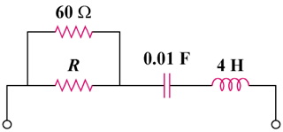

Figure 8.68
For Prob. 8.13.

